Background
The USDA Forest Service Eastern Forest and Western Wildland Environmental Threat Assessment Centers are collaborating with federal and university partners to develop strategic research components for the National Early Warning System. These new tools help natural resource managers rapidly detect, identify, and respond to unexpected changes in the nation’s forests and wildlands impacted by insects, diseases, wildfires, extreme weather, or other natural or human-caused events.

Among these new Early Warning System components is ForWarn, a satellite-based monitoring and assessment tool that provides a near-real-time national overview of potential forest disturbances to direct attention and resources to locations where forest behavior seems unusual or abnormal. A prototype version of ForWarn has produced national maps every eight days since January 2010, identifying locations that may require further investigation. The satellite imagery is interpreted and delivered through a suite of products, including the web-based Forest Change Assessment Viewer, a tool that provides an 8-day coast-to-coast snapshot of the US landscape and produces geographically relevant maps. ForWarn is intended to complement and focus efforts of existing forest monitoring programs.

ForWarn partners include NASA Stennis Space Center, US Geological Survey, the Department of Energy, and the University of North Carolina Asheville’s National Environmental Modeling and Analysis Center.

Additional decision support tools include the web-based Wildland Threat Mapper and the Threat News Explorer. The Threat Mapper integrates existing national risk maps into a single mapping environment, and allows natural resource managers to examine projected risks from multiple, interacting threats. Targeted mappers include the West-Wide Climate Change Mapper, Seed Zone Mapper, and the Cumulative Insect and Disease Mortality Mapper. The News Explorer is a media search engine customized to find and map global environmental threats, highlighting common wildland threats.

Key Messages
- The National Early Warning System is a strategic Forest Service effort in collaboration with Federal, State, non-governmental, and other partners that detects forest and rangeland disturbances and supports the Secretary of Agriculture’s vision for an all-lands approach to forest management.
- The Eastern and Western Threat Center products facilitate access to environmental threat assessment information related to natural and human-caused disturbances, including insects, disease, wildfires, hurricanes, urbanization, landslides, drought, flood, and year-to-year climate change.
- The Eastern and Western Threat Centers developed the satellite-based ForWarn that recognizes and tracks forest changes and uses the Forest Change Assessment Viewer to allow users to compare disturbance maps and share findings with other users.
- ForWarn, the Forest Change Assessment Viewer, the Wildland Threat Mapper, and Threat News Explorer help state, federal, and non-governmental forest and natural resource managers, scientists, and decision makers better identify, understand, and react to environmental disturbances and threats across the nation’s landscape.

- The Threat Centers’ forest and wildland disturbance detection products are the result of ongoing cooperation among federal and university partners.
- The Eastern and Western Threat Center products complement additional National Early Warning System efforts, including products focused on early detection of forest disturbances from the Forest Service’s Forest Health Protection, Forest Health Monitoring, and Remote Sensing Applications Center.
Questions and Answers
What is the National Early Warning System?
The Healthy Forests Restoration Act of 2003 specified development of a comprehensive early warning system to detect potential catastrophic environmental threats to forests. The National Early Warning System identifies and detects potential and actual threats, assesses impacts, and aids response influencing coordination of resources and efforts by various programs, agencies, and organizations.

What is ForWarn?
ForWarn provides a strategic, national overview of potential forest disturbances, identifying and directing attention and resources to locations whose forest behavior seems unusual or abnormal. Operational since January 2010, the satellite-fed ForWarn uses web-based tools to generate national disturbance maps, covering the entire lower 48 United States every 8 days. ForWarn uses the web-based Forest Change Assessment Viewer to interpret imagery and produce geographically relevant maps.

What are the Wildland Threat Mapper and Threat News Explorer?
The Wildland Threat Mapper and Threat News Explorer are additional decision support products. The web-based Threat Mapper is a tool that integrates existing national risk maps into a single mapping environment and highlights projected risks from multiple, interacting threats. The News Explorer is a media search engine that finds and maps articles related to global environmental threats, with an emphasis on wildland threats.

Who Can Use the New Eastern and Western Threat Centers’ Products?
Natural resource managers, scientists, and decision makers can use ForWarn, the Forest Change Assessment Viewer, the Wildland Threat Mapper, and the Threat News Explorer to better identify, understand, and react to disturbances and threats across the nation’s landscape.

What are Other National Early Warning System Components?
The National Early Warning System also includes products developed by the Forest Service’s Forest Health Protection, Forest Health Monitoring Program, and Remote Sensing Applications Center. These efforts target insect and fire-related disturbance detection and also provide access to maps and additional background data.

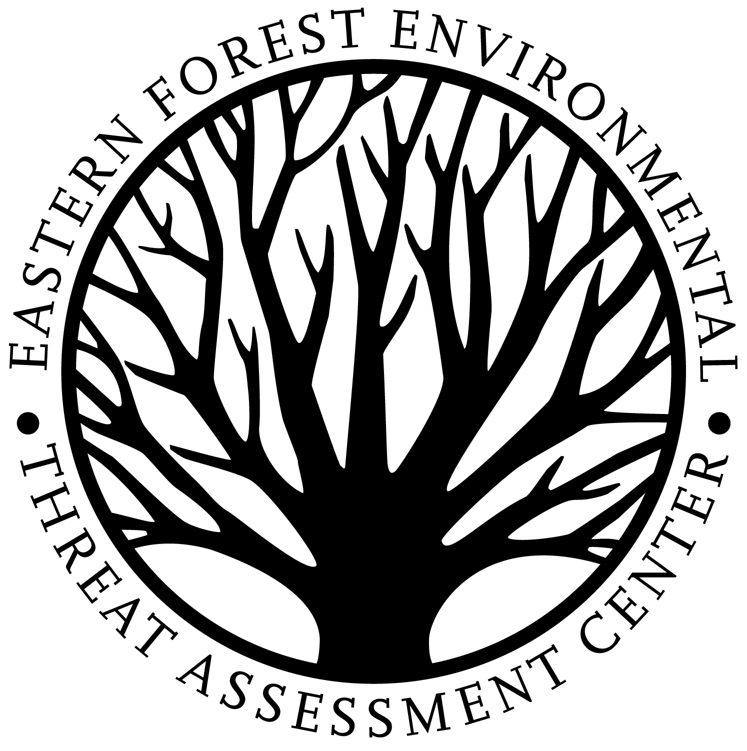
Contact
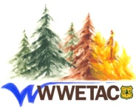
For additional information and training sessions, please contact Bill Hargrove, Eastern Center ForWarn lead researcher, at (828) 257-4846, email whargrove@fs.fed.us; Alan Ager, Western Center Wildland Threat Mapper lead researcher, at (541) 278-3740, email aager@fs.fed.us; Bill Christie, Eastern Center GIS specialist, at (828) 257-4370, email wchristie@fs.fed.us; or Sean Schroeder, Western Center remote sensing specialist, at (541) 383-6602, email swschroeder@fs.fed.us.

You may also wish to visit http://forwarn.forestthreats.org and http://www.fs.fed.us/wwetac/threat_map/index.html to learn more about these tools.

